MINEDUC
MUHANGA DISTRICT

EXAMINATIONS OF TERM II 2025-2026

S6 COMPUTER SCIENCE

GENERAL INSTRUCTIONS
- Read all questions carefully.

Answer all questions in Section A (55 MARKS).
- Answer only three (3) questions in Section B (30 MARKS)

Answer only one (1) question in Section C (15 MARKS).
- Show all workings, diagrams, or code where necessary.
- Marks for each question or sub-question are indicated

Section A: Attempt all questions. (55 marks)
  - Choose and circle the letter corresponding to the correct answer.
What is the most important safety precaution to take when cleaning a laptop?
    - Use harsh chemicals.
    - Power it off and unplug it.
    - Clean while it's running.
    - Don't worry about safety precautions.
  - What does 'backup' refer to in computer usage?
    - Updating software regularly
    - Storing duplicate copies of data files
    - Restarting the computer to fix issues
    - Deleting unnecessary files

  - Select the best answer for the following expression:
- 11102 + 11112
  - 110012
  - 111012
  - 111002
  - 101012

- 101011102 – 1001102
  - 100010002
  - 101010002
  - 100011002
  - 100010012

- 17.12510 = () 2

  - 11001.0012
  - 10011.0012
  - 10001.0012
  - 10101.0012

  - What is the purpose of video compression in digital video editing?

    - To increase video quality
    - To reduce file size
    - To add visual effects
    - To adjust colour grading

  - The binary tree below is represented as: ()
A
/ \
B C
/ \ \
D E F
Evaluate the Pre-order, In-order, and Post-order traversals of the given binary tree and select the correct option for each traversal.

Options:
- Pre-order Traversal
  - A, B, D, E, C, F
  - B, D, E, A, C, F
  - D, B, E, A, C, F
  - A, C, F, B, D, E

In-order Traversal
  - A, B, D, E, C, F
  - D, B, E, A, C, F
  - B, D, E, A, F, C
  - A, C, F, B, D, E

Post-order Traversal
  - A, B, D, E, C, F
  - B, D, E, A, C, F
  - D, B, E, F, C, A
  - D, E, B, F, C, A

  - What is the purpose of database security?
    - To ensure databases are always available
    - To protect databases from unauthorized access and data breaches
    - To optimize database performance
    - To design database schemas

  - Which of these is a primary component of LAN architecture?
    - Printer
    - NIC (Network Interface Card)
    - Monitor
    - Keyboard

  - Which step is part of setting up a wireless router for network connectivity?

    - Enabling file sharing
    - Configuring DHCP settings
    - Building Ethernet cables
    - Installing network drivers

  - Select the best output of the following program, and explain why?

#include
<iostream> using namespace std; int main() {
int x = 7, y = 5;
cout << (x == y) << endl; cout << (x > y)
<< endl; cout << (x != y) << endl; return 0; }
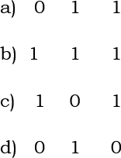

Explanation:

  - Match the HTML elements with their purposes:
    - <h1> i) Adds a paragraph.
    - <p> ii) Defines a hyperlink.
    - <img> iii) Adds a top-level heading.
    - <a> iv) Embeds an image.

  - i) Why is the Scanner class preferred for reading user input?
    - It provides synchronized methods.
    - It offers convenient methods for parsing primitive types and strings.
    - It directly connects to file streams.
    - It is faster than other input methods.
- What is the primary purpose of Apache Tomcat?
  - To manage databases
  - To serve Java applications
  - To compile Java code
  - To design GUIs

  - i) What is the role of the Front End in a Visual Basic project?
    - To manage and store data in a database.
    - To handle the logic and functionality of the application.
    - To provide the user interface for interacting with the application.
    - To optimize the performance of back-end processes.
- What function is used to display a message box in Visual Basic?
  - InputBox
  - MessageBox
  - MsgBox
  - Print
  - Determine whether the following statements about the differences
between static and dynamic web pages are True or False:
    - Static page load faster as they don’t rely on back-end processes…………………
    - Static pages show fixed content, while dynamic pages

update based on user input……………………
    - Static pages need server-side scripting, dynamic pages do not.
………………………….

PART 2: ANSWER by true or false.
  - Determine whether the following statements about the importance of proper file space allocation strategies in operating systems are True or False:

    - Proper allocation does NOT significantly affect disk space or fragmentation……………..
    - Improper allocation can slow down data retrieval and increase resource use………………
    - Efficient allocation improves system performance by reducing management overhead………………
    - File allocation is only crucial for large systems, NOT small ones………..
    - A good allocation strategy compromises system reliability and recovery……………
  - i) What is the purpose of relational algebra? Select best answer.
    - To query databases using mathematical operations
    - To secure databases from unauthorized access
    - To design database schemas
    - To manipulate data in databases.
ii) Match the following types of data integrity with their correct definitions:

Type of Integrity | Definition
1) Entity Integrity | a) Restricts data type, format, or range of values allowed in a column.
2) Referential  Integrity | b) Ensures foreign key values in a table correspond to primary keys in  another table.
3) Domain  Integrity | c) Every table row must have a unique  Identifier (Primary Key).
4) User-Defined  Integrity | d) Enforces specific business rules outside the above categories.

  - Develop a VB 6.0 or VB. net application that allows user
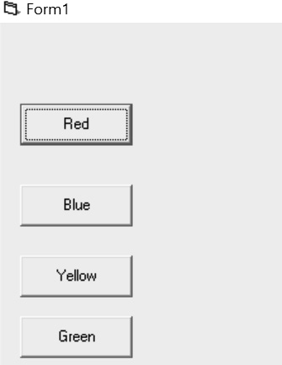
to change the background colour of the form in the sequence of red, blue, yellow, and green depending on a command button clicked as shown here below:

  - A) Analyse the program given below and give its output appropriately.

#include
<iostream> int main() {
int arr[5] = {10, 20, 30, 40, 50};
int *ptr = &arr[4];
std::cout << "Elements of the array accessed using pointer:\n"; for (int i = 0; i < 5; ++i) {
std::cout << "Element " << sizeof(arr)/sizeof(int)-i << ": " << *(ptr-i) << std::endl;
}
std::cout << "\nModified elements of the array using pointer:\n"; for (int i = 4; i >=0; i--) {
*(ptr-i) += 5;
std::cout << "Element " << 5-i << ": " << arr[4-i] << std::endl;
}
return 0;
}

B. Draw a flowchart to add even numbers from 0 to 20.

SECTION B: ATEMPT ONLY THREE (3) QUESTION QUESTIONS/30
marks
Question 1: A. differentiate the types of c++ data types and give examples for each type
B. Suppose you are hired by Rwanda Coding Academy (RCA) School to as a senior developer/programmer, and you are requested to develop a Student Academic Grading System,
A RCA (SCHOOL) wants a program that helps Lecturers process student results. The system should:
- Accept student name and marks
- Use a function called calculateGrade()
- Apply the following conditions:

Marks | Grade
70 – 100 | A
60 – 69 | B
50 – 59 | C
Below 50 | F
TASKS:
- Write a C++ program that:
  - Uses a function to return the grade
  - Uses if–else statements
  - Displays:
Student Name, Marks, Grade
- Explain why a function is important in this system.
Question 2: suppose that RSSB hired you a a backend developer to ddevelop the Employee Salary Bonus System
A RSSB wants to calculate bonuses for employees based on their years of experience.
Bonus conditions:
  - Experience ≥ 10 years → 20% bonus
  - Experience ≥ 5 years → 10% bonus
  - Experience < 5 years → No bonus

TASKS:
- Write a C++ program that:
  - Accepts employee name, salary, and years of experience
  - Uses a function calculateBonus()
  - Returns the bonus amount
- Use logical and relational operators in your solution.
Question 3: Facebook hired you as an software Engineer, they want you to develop/program the Secure Login System
A system allows a user to log in with:
  - Username: admin
  - Password: 1234 The program must:
  - Use a function login()
  - Allow only 3 attempts
  - Display “Account Locked” after 3 wrong attempts TASKS:
- Write the C++ program using:
  - Loop
  - Conditional statements
  - Boolean function
- State the role of bool in this program.
Question 4: Suppose that Kabgayi Hospital hired you a Database senior programmer to develop a Database System
A hospital wants to store information about:
  - Patients
  - Doctors
  - Appointments TASKS:
- Create a database called HospitalDB.
- Write SQL statements to create the following tables with constraints:

Patients
  - PatientID → Primary Key
  - Name → NOT NULL
  - Email → UNIQUE

Doctors
  - DoctorID → Primary Key
  - Name → NOT NULL
  - Specialization

Appointments
  - AppointmentID → Primary Key
  - PatientID → Foreign Key
  - DoctorID → Foreign Key
  - AppointmentDate → NOT NULL
- I) define: a) database b) constraints c) backup d) RDBMS e)Nosql f)DBMS
ii) List 5 types of database iii) explain the difference between ERD from DFD?
- What are the types of database design?
- Differentiate the types of constraints
- Draw the ERD of kabgayi Hospital

Question 5:ST DEOS School Database User Control (5 marks)
A ST DEOS school wants to control access to student records. TASKS:
  - Create a table Students with:
    - ID (Primary Key)
    - Name (NOT NULL)
    - Age (CHECK Age ≥ 5)
  - Create a user called teacher with your own password.
  - Grant the teacher: SELECT and INSERT
  - Revoke INSERT from the teacher.
  - I) differentiate the types of normal forms

- Differentiate the types of database
- Explain the DFD symbols, their meaning and their uses
- Write a query (only the syntax) to delete a column name ,update a record ,delete a table name permanently and add new column.

SECTION C: ATTEMPT ONLY ONE(1) QUESTION /15 MARKS

  - Write the HTML codes which will display the following output:

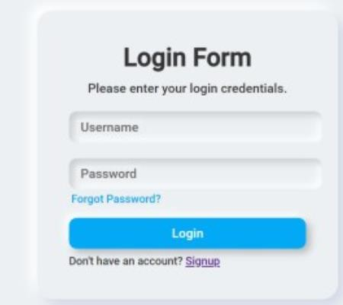

Note: 1. once you click on forgot password? Link immediately directs you to the create new password FORM by using the email you have used in Signup form.
  - Once you click on signup as link, it will direct you immediately to the CREATE ACCOUNT home page as in Signup form.

2. Write an HTML codes to display the following output:
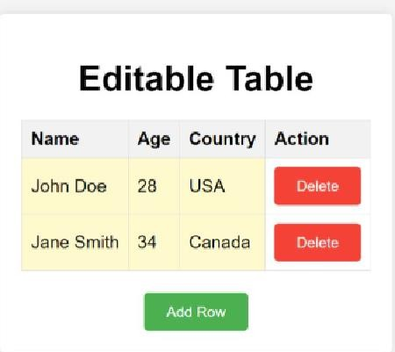

END-

