PHYSICS S3 – MARKING GUIDE
1. a) F /1 mark
b) F /1 mark
c) T /1 mark
2. d) F – Static friction acts on a stationary body. /1 mark
e) F – Friction opposes motion. /1 mark
3.a) Repel /1 mark
b) Electric field intensity /1 mark
c) Decreases /1 mark
4. a) (ii) 2 m² /1 mark
b) (iii) 1600 cm² /1 mark
5. a) Altitude, humidity, wind, temperature /1 mark
b) Given data:
- h = 9 m
- ρ = 1000 kg/m³
- g = 9.81 N/kg
Pressure:
P = ρgh
P = 1000 kg/m³ × 9.81 N/kg × 9 m
P = 88,290 Pa /2 marks
6. a) (i) Conduction /0.5 mark
(ii) Convection /0.5 mark
b) (i) First /0.5 mark
(ii) Inertia /0.5 mark
c) (i) Second / 0.5 mark
(ii) Acceleration /0.5 mark

7.a → ii /1 mark
b → i /1 mark
c → iv /1 mark
d → iii /1 mark

8.a) (iii) Ampere /1 mark
b) (iv) Kilowatt-hour /1 mark
c) (ii) 12.0 V /1 mark
d) (iv) 7.0 Ω /1 mark
e) (i) High melting point and low resistance /1 mark
f) (ii) 16 /1 mark
9. V₀ = 108 km/h $=\frac{-108×1000m}{3600 Sec}$=30 m/s
V_{f} = 0
t= 15 Sec
- Deceleration (a) $=\frac{Vf-Vo}{t}=\frac{0-30m/s}{15S}=-2 m/s2$ /1 mark
- D= Vo t +$\frac{1}{2}$ at²

= 30m/s × 15S - $\frac{1}{2}$×2m/S² × (15S)²

= 450m-225m=175m /2 marks
10.
Linear Momentum | Impulse
Product of mass and velocity | Product of force and time
P=m×V | I=F×t
SI unit: kg·m/s | SI UNIT: N·s

(b) Δp=I
mV_{f}−mV₀=I

Impulse
10×8−10×4 =I
80−40= I

Impulse = 40 kg m/s or 40 N.s /2 marks

(C) i) Inelastic Collision K E is not conserved.
ii) m_{1​=}600 kg
u₁​=4 m/s
m₂​=1200 kg
u₂​=0 (stationary)
= p₁​+p₂​=(m₁​+m₂​)V ,V is common Velocity
(600×4)+(1200×0)=(600+1200)V
2400=1800V
2400=1800V
V=$\frac{2400}{1800}$=1.33 m/s

The Common velocity after collision = 1.33 m/s /2marks

11.
a) (i) 34+273=307K / ½ marks
(ii)300−273=27 ⁰ C / ½ marks

b) i) A is cork lid / ½ marks

B is vacuum / ½ marks

C is inner silvered glass / ½ marks

D is outer silvered glass / ½ marks

(ii) Vacuum /1 mark

(iii) Silvered glasses /1 mark

12 a) Sun ,Stars ,Lamp,…………….. /1 mark
b) i) Virtual, Smaller erector Upright , behind the mirror / 1 mark
ii) The Same size, Upright , Equidistant Laterally inverted /1 mark
c) Applications of spherical mirrors:
. Rear-view mirrors
. Dentist mirrors: To magnify teeth for better examination
. Reflectors , …………………………………………./1 mark

13 a) (i) Pressure is inversely proportional to the Volume /1 mark
b) (ii) increase /1 mark
c) (iii) increased /1 mark

14 a) Axe: wedge /1 mark
b) Flagpole: Pulley (single fixed pulley) /1 mark
c) Bottle opener: lever (second class of lever) /1 mark
d) steering wheel: wheel and axle /1 mark

15. a) ΔU = Q + W, Q = +500J (system gained heat)
W = −200J (system does work)

ΔU = +500J + −200J = 300J /2 marks

b) 1. compressor /½ mark
2. condenser /½ mark
3. Expansion Valve /½ mark
4. Evaporator ½ mark

SECTION B

16 .a) B
b) (iii) 9 × 10⁹ $\frac{Q}{d}$
c) i)
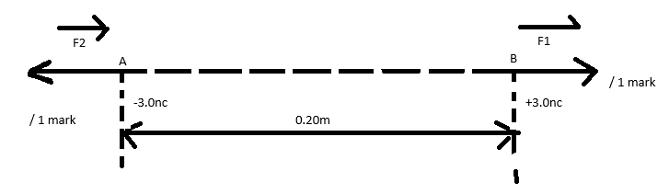

ii) F= ​​$\frac{kQ1×Q2}{d2}$=$\frac{9.0×109×-3×10-9×(+3.0×10-9)}{0.20ₓ0.20}$ / 1 mark
F=−2.025×10⁻⁹ N /1 mark
d) (i)
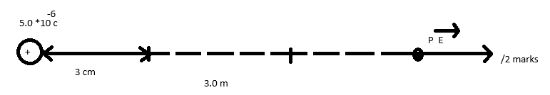
(ii) E=$\frac{kQ}{d2}$=9×10⁹×5.0×10⁻⁶ /(3)2 =45×10³9 N/C
E = E=5×10³ N/C=5000 N/C /2 marks

17. a)
Renewable energy sources | Non-renewable energy sources
- Can be renewed  - Exist forever / will never run out  - Can be used more than once time  - They exist in natural environment  - They do not pollute atmosphere  Examples: solar energy, wind energy, water energy, geothermal | - Can not be renewed  - They will never run out  - They exist in fixed quantity  - They are used once time then get depleted  - Most of them exist in underground part of the Earth  - They pollute atmosphere  Examples: Fossil fuels, nuclear fuels

b) KE of moving water → PE of falling water
KE of rotation of turbine → Electrical energy /2 marks
c) (i) Microphone
(ii) Electric motor
d) m = 72 kg, h = 2.5 m, t = 25 sec
e) Work done = mgh = 72 × 10 × 2.5 = 1800 J
b) Power (P) = W/t = 1800 J / 25 sec = 72 watts
- a) Initial velocity is 5 m/s /1 mark
b) a= $\frac{Vf-V0}{t}$ =$\frac{10-5}{10}$=$\frac{5}{10}$ =0.5 m/s² /2 marks
c) a= $\frac{Vf-V0}{t}$ =$\frac{0-10}{10}$=$\frac{10}{10}$ = -1 m/s² = /2 marks
d)
A = A body accelerates uniformly from 5 m/s to 10 m/s in 10 sec / 1 mark
B = A body moves at constant velocity in 10 seconds / 1 mark
C = A body decelerates uniformly from 10 m/s to rest in 10 sec / 1 mark
e)D_{A}=V₀t+$\frac{1}{2}$12at²=5×10+$\frac{1}{2}$×0.5×(10)² = 50 + 25 = 75 m /1 mark
D_{B}=V_{o}t=10m/s×10sec=100m /1 mark

D_{C}=V₀t+$\frac{1}{2}$at²=10×10−$\frac{1}{2}$×1×(10)²
= 100 - 50 m = 50 m /1 mark
Total distance = D_{A}+D_{B}+D_{C}=(75m+100m+50m) = 225 m
19. a) (i) Melting: is the change from solid to liquid / 0.5 mark
(ii) Boiling: is the change from liquid to gas which occurs at constant temperature./ 0.5 mark
(iii) Melting point: Is a constant temperature at which solid changes into liquid / 0.5 mark
(iv) Boiling point: Is a constant temperature at which liquid changes into gas. / 0.5 mark
b) α = 3δ , α = coefficient of linear expansion / 2 marks
δ = coefficient of Volume expansion.
- i)Q₁ = mc Δθ = 2.0 × 4.18000 × 40°C
= 42000 J (1 mark)
Q₂ = mL = 2.0 × 3.6 × 10⁵ = 720000 J /1 mark
Q₃ = mc Δθ = 2.0 × 4200 × 20°C = 168000 J /1 mark
Total amount of heat = Q₁ + Q₂ + Q₃ = 930,000 J
ii) Assumption made is that electrical energy spent is equal to the amount of heat required / 1 mark
E= Q / 0.5 mark i.e Pᵡt = Q absorbed / 0.5 mark / P= 1.0 Kw= 1000 W
1000 w × t= 930 000 J / 0.5 mark t=$\frac{930 000 J}{1000 W}$ =930 Sec / / 0.5 mark

- (i) The current will be induced in the wire (The needle of galvanometer will deflect) /2marks
(ii). Increase the number of turns
• Increase the speed of the wire i.e make it move fast as possible 1 mark
• Use the stronger magnet (iron one) 1 mark
b) Given data:
Vp = 240 V
Vs = 12 V
P output = 20 W (secondary power)
Ip = 1 A
- Power supplied to the primary circuit ( input power) = I _{p}V p
=1A$×240 V=240 W$/ 2 marks
- Power developed in secondary coil is 20 W$×10 lamps$= 200 W/ 2 marks
- Efficiency of a transformer=$\frac{Power output}{Power input}×100\%=\frac{20 0W}{240W}×100\%$= 83.3% / 2 marks
SECTION C

21.a) Ammeter: 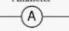
b) On graph paper

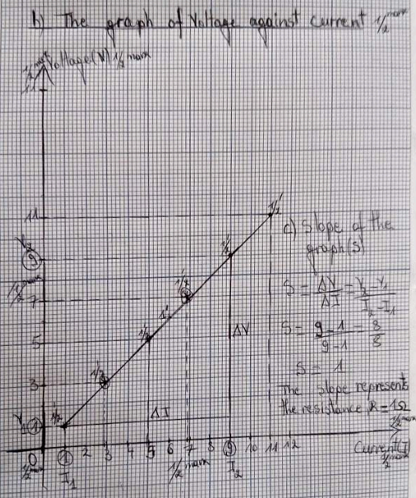

c) slope = $\frac{Δy}{Δx}$ =$\frac{ΔV}{ΔJ}$ =$\frac{V2-V1}{I2-I1}$ =$\frac{9.0-5.0}{9.0-5.0}$ =$\frac{4}{4}$=1 / 1 mark
It represents resistance. / 1 mark

d) • Amount of electric current
• Resistance ( 1 mark for each factor)
• Time in which current flows

e) • Precautions to be taken while working with electricity:
• Switch off the main power supply before starting. ( any 1 mark for precaution)
• Do not touch electrical appliances with wet hands.
• Check where the main fuse or circuit breaker is.
END

