MUHANGA DISTRICT
MARKING SCHEME OF MATHEMATICS EXAMINATION FOR SENIOR TWO 2ND TERM

- The matches are:
1 → B /1mark
2 → C/1mark
3 → A /1mark
- Option is d. 7x + 2 /3marks
- option d. 6 / 3marks
- Answer: a. $x=\frac{2}{3}$ / 4marks
- Answer: d. 1 / 4marks
- Answer: d. 10x+6y 3marks
- Answer: c. $-\frac{13}{8}$ /3marks
- The correct answer is: b. 5(2−$\sqrt{3}$) 4marks
- a. False /1mark
b. True /1mark
c. False /1mark
d. False /1mark
10. The best answer is: b. $a=3 ,b=2$ /4marks
11.The correct answer is b.{(2,1)} 4marks /
12. The best answer is a. $x=12cm /4marks$
13.The best answer is $b. P=20.68cm /4marks$
14.The best answer is b.1040litres /4marks
15. The best answer is d. {$(2,-1)\}$ /4marks

SECTION B: ATTEMPT ANY THREE QUESTIONS /45MARKS
16. $ε=120$
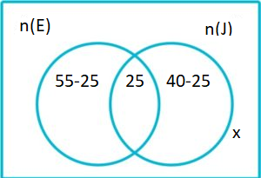
$x+30+25+15=120$ /6marks
$$x+70=120$$
$$x=120-70$$
$$x=50$$
b. People who had neither Eggs nor Juice $=50$ /3marks
c. People who ate Eggs only $=55-25=30$ /3marks
d. People who drank Juice only $=40-25=15 /3marks$
17. a. $\frac{2}{3}x-5≤2x-1$
$\frac{2}{3}x-2x≤-1+5$
$\frac{2x-6x}{3}≤4$ ,$-4x≤12, x≥- 3$ /4marks
b. Factorize: : 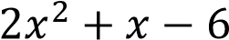
$2x^{2}+4x-3x-6$
$2x(x+2)-3(x+2)$
$(x+2)(2x-3)$ /5marks
c. A(4,0) ,B(O,3) C(4,3)
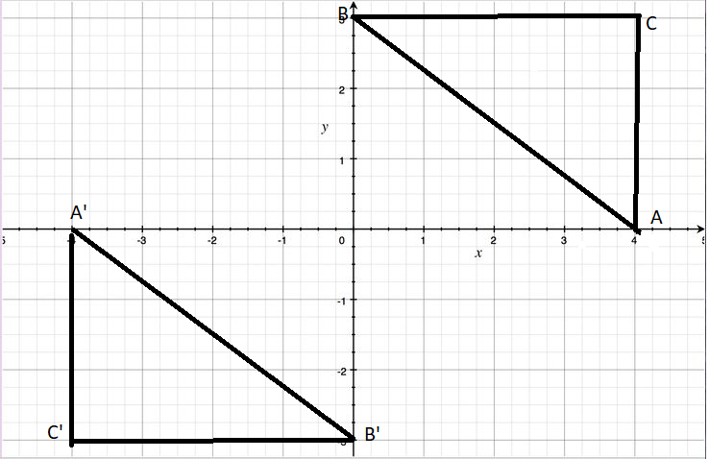
A’(-4,0)
B’(0,-3)
C’(-4,-3)
Each point marked 1mark

- 18.a)
  - The coordinates of OA $=\left({2 \atop 1}\right)$ /1mark
  - The coordinates of OB$=\left({2 \atop 5}\right)$ /1mark
iii) The coordinates of OC $=\left({6 \atop 1}\right)$ /1mark
- The column vector for : i) AB$=0B-0A=\left({2 \atop 5}\right)-\left({2 \atop 1}\right)=\left({0 \atop 4}\right)$ /2marks
ii) BC$=0C-0B=\left({6 \atop 1}\right)-\left({2 \atop 5}\right)=\left({4 \atop -4}\right)/ 2marks$
iii) AC$=0C-0A=\left({6 \atop 1}\right)-\left({2 \atop 1}\right)=\left({4 \atop 0}\right)$ /2marks
- The length of line segment: i) $\left|AB\right|=\sqrt{0^{2}+4^{2}}$ $=\sqrt{16}=4 ul$ /1mark
ii) $\left|BC\right|$ $=\sqrt{4^{2}+{(-4)}^{2}}=\sqrt{16+16}$ $=\sqrt{32}$ $=5.65 ul$ /1mark
iii) $\left|AC\right|=\sqrt{4^{2}+0^{2}}=\sqrt{4^{2}}=4 ul$ /1mark

$d) Since two sides are equal, So triangleABC is Isosceles triangle$ (AB$=AC$) /3marks
19.a. $Let x be the smaller number and y be the larger number$
$x+y=17$ $,x=17-y(1)$ /1mark
$2y-4=3x(2)$ /1mark
$substitute equation \left(1\right)in \left(2\right)→2y-4=3(17-y)$ /1mark
$→2y-4=51-3y$
$→2y+3y=51+4$
$→5y=55 ,y=11$ /1mark
Substitute the value of y in $x+y=17 ,x+11=17 ,x=17-11 ,x=6$ /1mark
Thus, the smaller number is 6
The larger number is 11
b. Solve the inequality:
$\frac{3-x}{x+2}-4>0 → \frac{3-x-4\left(x+2\right)}{x+2}>0 → \frac{3-x-4x-8}{x+2}>0 → \frac{-5x-5}{x+2} >0$/2marks
Case1:$-5x-5>0 and x+2>0 or$/1mark
Case2:$-5x-5<0 and x+2<0$/1mark
Solving case 1:$-5x>5 ,x<\frac{5}{-5} , x<-1 and x>-2$
From the number line, the solution sets includes all $x between -1 and -2$, so $-2<x<-1$ /1mark
Note: we can also use the table of sign to show the required solution.
c. $f(x)=x+20x^{2}-4$ and $g(x)=4+5x$
Rearrange the terms in the dividend and the terms in the divisor
$$f\left(x\right)=20x^{2}+x-4 and g\left(x\right)=5x+4/1mark$$
By using long division of polynomials,$\frac{f\left(x\right)}{g(x)}, Quotient=4x-3 and the remainder=8$ /4marks
20. Frequency distribution table :each column marked 2marks 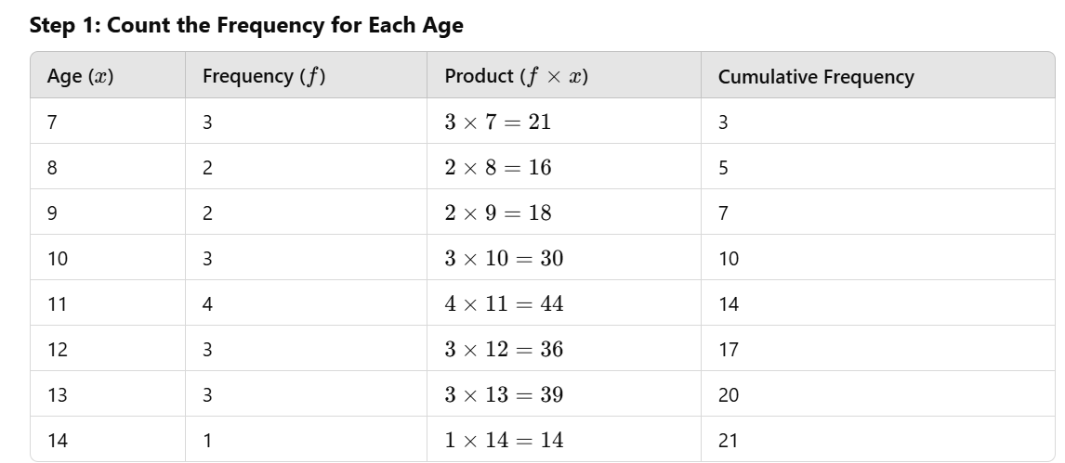
$\sum{f=21}/1mark$ $\sum{fx=}218 /1mark$
b. The number of students are in the group is 21 /2mark
c. $The mean age=\sum{f\left(x\right) ÷ \sum{f}}=\frac{218}{21}=10.38 years$ 2marks
d. The mode age is 11Years because its highest frequency of 4 /1mark
e. The median age $=\frac{Xn+1}{2}=\frac{X(21+1)}{2}=\frac{X22}{2}=X11=11$ /2marks
