Muhanga district.
EXAM: Biology and health science (theory).
Class: Senior two
Term: Two
DATE: …. /3/2026
PERIOD: 9H00-12H00
. This paper consists of three sections: A, B, C
. Sections A: Attempt all questions.
. Sections B: Attempt three questions.
. Sections C: This section is compulsory.

SECTION A (ATTEMPT ALL QUESTIONS)/55marks
- Mention True or False/7marks
- Active transport is fastest within the optimum range.
- Pinocytosis means cell drinking.
- Exocytosis is the process by which molecules are released to the inside of the cell.
- If you place a cell in isotonic solution, the size of cell will increase.
- Diffusion is a movement of molecules from an area of lower concentration to an area of higher concentration.
- If you place a cell in hypertonic solution, the size of cell will decrease.
- Osmosis is a special type of diffusion.
- Which of the following forms a pair of homeothermic (warm blooded) animals? / 1mark
- Mammals and birds.
- Amphibians and fish.
- Reptiles and mammals.
- Amphibians and reptilians.
- Which of the following describe osmosis? /1mark
- Movement of sugar molecules.
- Movement of water molecules.
- Movement of sugar and salt molecules.
- Evaporation of water.
- Enzymes are ……………….in nature. /1mark
- Starch b) Protein c) Carbohydrates d) Lipid.
- In which part of the respiratory system does gaseous exchange take place? /1mark
- Alveoli b) Pharynx c) Larynx d) Trachea.
- Amylase is a digestive enzyme found in the saliva. Which of the following food substances does its breakdown? /1mark
- Glucose b) Starch c) Protein c) Carbohydrates.
- Which of the following form a pair of decomposers? /1mark
- Mucor and amoeba
- Protozoan and bacteria.
- Bacteria and fungi
- Tape worms and earthworms.
- The total magnification of microscope is calculated by multiplying the magnification of ocular Lense by the magnification of objective lens. If the ocular Lense magnifies 10x and the objective lens magnifies 40x. what is the total magnification. /1mark
a) 4x b) 4000x c) 400x d) 40x
9. Food samples were tested by boiling them in benedict solution. It gave an orange precipitate. This showed that the food sample contained:/1mark
a) Reducing sugar b) Water C) Proteins d) Carbohydrates.
10. Which of the following substances is the most abundant compound in a living cell? /1mark
a) Fat b) Water c) Proteins d) Carbohydrate.
11. Why is breast milk a form of immunity for a baby? / 1marks
a) Because it has proteins.
b) Because it has vitamins.
c) Because it has antibodies.
d) Because it has carbohydrates.
12. Match column A to column B/5marks
Column A | Column B
Cytology | It is the study of how a cell function
Genetics | It is the study of the chemical processes that take place within the body
Anatomy | It is the study of living organisms and their structure
Biotechnology | It is the study of gene and heredity
Physiology | It is the study of cell
- Which group of organism is both aquatic and terrestrial? /1mark
- Mammals b) Birds c) Amphibians d) Reptiles e) Fish
- Fill the following by using grasshopper, fleas, four, three.
…………. Is an Arachnids and has ……...pairs of legs, whereas ……...is an insect and has ……………. pairs of legs. /2marks
- True/ False questions/4marks
- Plants are essential for producing oxygen, which is necessary for the survival of most livings’ organisms on earth.
- Without plants, Earth would have an abundance of food sources for animals and humans.
- The absence of plants would lead to a significant decrease in the amount of carbon dioxide in the atmosphere.
- Without plant, there would be no habitat for many animal species, leading to a breakdown of ecosystem.
- Which of the following reasons explain why pregnant women should avoid drugs and alcohols during pregnancy. /1mark
- Drugs and alcohols can increase the chance of multiple birth.
- Drugs and alcohols can harm the development of baby’ brain immune system.
- Drugs and alcohols can help in the development of baby ‘immune system.
- Drugs and alcohol have ono effect on pregnancy outcome.
- Complete the sentences below using these words:/2.5marks
Toward phototropism, root, stimulus, negatively. Each would be used once. /5marks
- The growth of a stem ……… or away from a light ……… is called……….
- Plant stems are……………. gravitropism.
- Plant ………………………gravitropism.
- Copy the table below about disease and draw straight lines to match each of the terms to it best definitions. (2marks).
Term | Definition
1.Carriers | A. A disease in which the pathogen can be passed from one host to another
2. Pathogen | B. A poison which can be produced by some bacteria.
3. Toxins | C. A disease- causing organism.
4.Infectious disease | D. A person who carries pathogen without showing any sign of the disease.
19. students investigate how PH affects the activity of pepsin; a protease enzyme found in A the stomach. The enzyme was mixed with protein solution at different PH values. The greater rate of protein digestion occurred at PH 2.
- Which liquid in the stomach provides the acidic PH for pepsin to work effectively. /1mark
i)Saliva ii) hydrochloric acid iii) Pancreatic juice iv) Bile
- Pepsin works best at PH 2 because it is adapted to: /1mark.
i)Alkaline condition ii) Neutral condition iii) Acidic condition.
iv) Warm water.
- What would happen to Pepsin if it was placed in a solution with PH 9? /1mark
i)It would work faster.
ii) It would remain unchanged
iii)It would denature and stop working.
iv)It would form more substrate.
- The optimum temperature for pepsin in human bodies is approximately. /1mark
i)25^{0c} ii) 37^{0c} iii)60^{0c} iv)20^{0c}
20. Match the word in column A with the correct statement in column B /2marks
Column A | Column B
1.carbohydrate | A. Needed for healthy skin and gums
2.Iron | B. Needed to build new cell
3.Proteins | C. Helps make hemoglobin in red blood cells
4. Vitamin C | D. Needed for energy

21.One of the following transports manufactured food away the leaves. Which one is it? / 1mark
a) Xylem b) Phloem c) Petiole d) Epidermis
22. The tiny pores on the leaves that allow transpiration are called……..?/1mark
a) Lenticel b) Stomata c) Root pressure d) Xylem vessels.
23. Which of the following increase the rate of transpiration? /1mark
a) High humidity b) Low temperature c) Strong wind d) Nighttime
24.Mineral salts are absorbed by roots mainly through. /1mark
a) Diffusion only b) Active transport c) Osmosis d) Transpiration pulls.
25. Copy and complete using the words below:/3.5marks
Concentration, active transport, osmosis, energy, against, mitochondria, diffusion, respiration.
26………(a)……and……. (b) ……depend on a ……. (c)……gradient in the right direction to work. Substances are moved ……. (d)……. a gradient by ……(e)……..which use ….(f)……produced by ……..(g)……. This process involved the release of energy is called…(h)………
27. What would happen if osmosis was not available in plants? /2marks
………………………………………………………………………………………………………
28. Explain the role of vascular bundles in plants. /2marks
……………………………………………………………………………………………………
29. Marine animals such as reptiles and birds live in extreme salt concentration, hence drink water with a lot of salt. How do they survive in such conditions? /2marks
………………………………………………………………………………………………………………………………………………………………………………………………………………
30.Expain why an elaborate transport system in unicellular organism is unnecessary? /1marks
……………………………………………………………………………………………………
31.Explain how malaria spreads from one person to another. /1mark
……………………………………………………………………………………………………
SECTION B: attempt only three questions/30marks
32. Use the diagram of the cross-section of the leaf to answer the questions that follow.
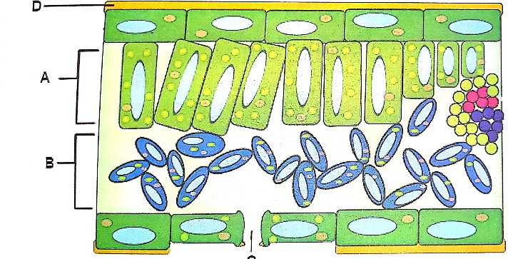
- Indicate on the diagram the following: guard cell, spongy mesophyll cell layer, palisade cell layer and vascular bundle. /2marks
………………………………………………………………………………………….
b) Which cell type absorbs most carbon dioxide during the day? /1mark
………………………………………………………………………………………………………
c) State the role of the part labelled D in photosynthesis. /1mark
………………………………………………………………………………………………………
d)Describe ways in which cell type B are suited for photosynthesis. /1mark
………………………………………………………………………………………………………
e) What importance is the shape of cell type C in photosynthesis. /1mark
………………………………………………………………………………………………………
f) Give four ways into which leaf is adapted to its function. /4marks
………………………………………………………………………………………………………………………………………………………………………………………………………………………………………………………………………………………………………………………………………………………………………………………………………………………………
33. a) What is enzyme?
………………………………………………………………………………………………………………………………………………………………………………………………………………
b) Describe the characteristics of enzymes (6marks)
………………………………………………………………………………………………………………………………………………………………………………………………………………………………………………………………………………………………………………………………………………………………………………………………………………………………………………………………………………………………………………………………………………………………
34. Using a table differentiate inhalation and exhalation phase of gaseous exchange in human. (10marks)
………………………………………………………………………………………………………………………………………………………………………………………………………………………………………………………………………………………………………………………………………………………………………………………………………………………………………………………………………………………………………………………………………………………………………………………………………………………………………………………………………………………………………………………………………………………………………………………………………………………………………………………………………………………………………………………………………………………………………
35. The figure below represents a feeding relationship in a terrestrial ecosystem.
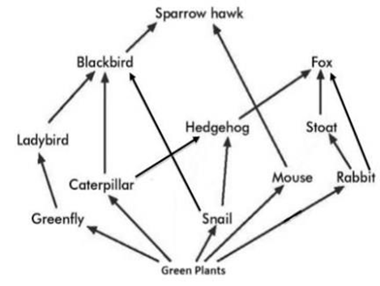
a) What name is given to the above diagram? (2 marks)
……………………………………………………………………………………………………
b) What do the arrows on the diagram mean? (1 mark)
……………………………………………………………………………………………………
c) green plants are producers. What does this mean? (2 marks)
……………………………………………………………………………………………………
d) Name two primary consumers from the above diagram. (2 marks)
…………………………………………………………………………………………………….
e) Name any two carnivores from the above diagram. (2 mark)
………………………………………………………………………………………………………
f) To which trophic level does the hedgehog belong? (1 mark)
……………………………………………………………………………………………………..
36. A group of senior students conducted an experiment using two samples: RED BLOOD CELL (animal cell) and ONION EPIDERMIS (plant cell). Both samples were placed in pure water for 15minute. After observation under the microscope, the student noticed that the red blood cells burst, but onion cells remained intact and filmed.
Answer the following questions based on the case study
- State and define the process by which water entered both types of cells.? (3marks).
………………………………………………………………………………………………………………………………………………………………………………………………………………………………………………………………………………………………
- Explain why water moved into the cell. (2marks)
………………………………………………………………………………………………………………………………………………………………………………………………
- Describe what happens to the red blood cells after being placed in water. (2marks)
………………………………………………………………………………………………
- Explain why onion cells do not burst even though water enters them.? (2marks)
………………………………………………………………………………………………
- Suggest one importance of this process in living organisms. (1mark)
………………………………………………………………………………………………
Section C: Attempt any one question. (15 marks)
37. An experiment was carried out to find out if carbon dioxide is necessary for photosynthesis. Two plants of the same species were de-starched. The plants were then placed in sealed glass containers for 24 hours as shown in figures below and exposed to sunlight. Sodium hydroxide pellets were placed in glass container of plant A while glass beads were placed in the glass container of plant B. After 24 hours, starch test was carried out on plants A and B.

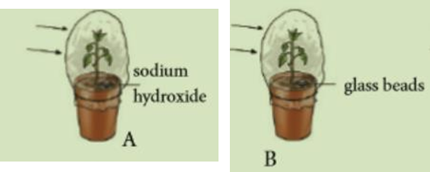
- Explain why the plants were de-starched before beginning the experiment. (1 mark)
………………………………………………………………………………………
b) Why is chlorophyll removed from the leaves before carrying out a starch test?
- marks) ………………………………………………………………………………..
c)What is the role of sodium hydroxide in the experiment? (2 marks)
……………………………………………………………………………………………
d) State the expected results of the starch test. (2 marks)
…………………………………………………………………………………………………………………………………………………………………………………….
e) Account for the results stated in (d). (2 marks)
………………………………………………………………………………………………………………………………………………………………………………………………
f) Why was plant B included in the experiment? (2 marks)
………………………………………………………………………………………………
g) What role is played by magnesium and nitrate ions in plants? (4 marks)
………………………………………………………………………………………………………………………………………………………………………………………………
END

