REPUBLIC OF RWANDA
SOUTHERN PROVINCE
MUHANGA DISTRICT ……^{th}/ MATCH / 2026
S1-MARKING GUIDE OF GEOGRAPHY AND ENVIRONMENT-END OF TERM II EXAM/100 MARKS
STUDENT NAMES …………………………………………………………………………
SECTION A: INSTRUCTIONS: Attempt ALL Questions. (70MARKS)
1. i) Who is regarded as the "Father of Geography"? (1marks)
- Aristotle C. Ptolemy
- Eratosthenes D. Galileo
ii) What type of rock is formed from the cooling and solidification of magma? (1marks)
- Sedimentary rock C. Igneous rock
- B. Metamorphic rock D. Fossil rock
iii) What is the name of a person who draws and produces maps? (1marks)
A) Cartographer C) Meteorologist B) Geologist D) Astronomer
iv) What is the purpose of the key (legend) on a map? (1marks)
- To show the title of the map
- To display the symbols and their meanings
- To indicate the cardinal directions
- To provide a description of the map’s history
2. i) The galaxy in which our earth belongs is called: (1marks)
- Andromeda galaxy C) Milky way galaxy
- Black eye galaxy D) Yellow galaxy
ii) It is the only star that gives out its own light. (1marks)
) Sun C) Moon
) Cluster D) Jupiter
iii) It is the only planet that supports life: (1marks)
- Mercury  - Earth | C)Venus  D) Mars
iv) The natural satellite of the earth is: (1marks)
- Moon C) Sun
- Stars D) Galaxy
3.) What type of rock is most likely to contain fossils? (1marks)
  - Igneous C) Sedimentary
  - Metamorphic D) Volcanic
4.i) Which of the following is NOT a source of geographical information? (1marks)
A. Internet B. Museums
C. Mathematics D. Atlases
ii) One of the following is NOT a method of indicating relief features on a map. (1marks)
A. Relief B. Contours
C. Trigonometric stations D. Spot heights
5.Fill the following sentences with the following words to make them meaningful. (4marks)
Equinox, Longitude, Solstice, Latitude.
- __ Latitude. __________________________is the distance of a point away from the equator expressed in degrees.
- Equal lengths of day and night are known as Equinox
- Longitude is the angular distance east or west of the prime meridian.
- Unequal lengths of day and night are known as_ Solstice
6. Choose and circle the correct answer.
i) What are the inner planets of the solar system? (1marks)
A. Jupiter, Saturn, Uranus and Neptune B. Jupiter, Mercury, Earth and Neptune
C. Mercury, Venus, Earth, Mars D. All answers are correct.
ii)Which planet supports life? (1mark)
A. Earth B. Mercury
C. Mars D. All answers are correct. iii)The following are the phases of moon except: (1mark)
A. Full moon B. Last quarter Moon
C. New moon D. Day moon
7.i) The process of soil horizon development is mostly related to the: (1marks)
A) Soil structure B) Soil profile
C) Soil texture D) Soil catena
ii) What is a soil catena? (1marks)
- The relationship between different soil types along a slope
- A horizontal layer of soil
- The process of soil erosion
- The collection of organic material in soil
8. Choose and circle the correct answer.
i) Which of the following is NOT an effect of the Earth's rotation? (1marks)
A) Day and night B) Seasons
C) Time difference D) Deflection of wind and ocean currents
ii) Among the following, what causes days and nights? (1mark)
A. Revolution B. Tides
C. Rotation D. A and C are correct answers.
9. Choose and circle the correct answer.
i) The path followed by planets around the sun is called: (1mark)
A) Axis B) Orbit
C) Longitude D) Latitude
ii) Among the following options, choose any 3 evidence to show that the shape of the earth is spherical and not flat are: (3marks)
- Aerial photographs D. Circumnavigation of the earth
- Four seasons E. Sunrise and sunset
- Universe
iii) Which type of eclipse is shown by the diagram below: (1mark)
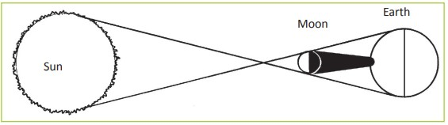
____Solar eclipse
10.Complete the following table with the correct element of the earth: (2marks) Biosphere, Lithosphere, Atmosphere, Hydrosphere
DESCRIPTION | ELEMENT OF THE EARTH
a) This is the part composed of all the water on the earth surface. | Hydrosphere
b) is the part that is composed of gases that surround the earth. | Atmosphere
c)This is the part of the earth where life exists. It includes all living things. | Biosphere
d)This is the solid outer part of the earth. | Lithosphere

- Answer the following statements by TRUE or FALSE (5marks)
    - The earth revolves around the moon. FALSE
    - The earth rotates in an Anticlockwise direction from West to East TRUE
    - The moon is a natural satellite of the earth TRUE
    - Pluto is no longer a planet because it is too small. FALSE
    - Rotation of the earth takes 365 days TRUE
- Study the diagram below and answer the questions that follow.

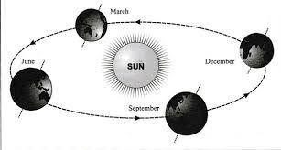
    - Which movement of the earth is represented by the diagram? (1mark). Revolution
    - Give Two effects of the movement represented by the diagram. (2Marks)
Change in seasons
Formation _of the year
13.Identify any 2 components of the universe? (2marks)
1. astroids
2. galax
3. comet
4. stars
14.a) Calculate the time of Kinshasa located at 45⁰W when the time at Greenwich meridian is 10:00 a.m. (2marks)
15⁰1Hour
1^{0____} 1hr x 45⁰/15⁰ ⁼ 3hrs
10:00 – 3hrs = 7:00 a.m.
b) What is the longitude of CITY Y whose local time is 9:00a.m, when the local time at Greenwich median is noon. (12:00pm). (2marks)
Difference in time: 12:00-9:00=3hours
15⁰1Hour
3hours x 15⁰=45⁰
The longitude at City Y is 45° West
15.Which of the following is NOT a source of geographical information? (1marks)
A. Internet B. Museums
C. Mathematics D. Atlases
16. Analyze the following statements using TRUE and FALSE. (5marks)
- An atlas index is a detailed alphabetical listing of names, places and topics_ True
- The shape of the earth is flat. _ False
- The earth rotates in an Anticlockwise direction from West to East_ True
- The moon is a natural satellite of the earth__ True
- Lunar eclipse occurs when Earth comes between Sun and Moon_ False
17. Muhire wants to indicate the height of a specific spot of an area on a map. Which combination comprises methods will he use to represent relief features on a map. (1marks)
- Colors, Contours, trigonometric stations, spot heights
- Altitude, relief, contours, colors
- Colors, Contours, height, Altitude
- All answers are correct
18. a) What are the inner planets of the solar system? (1marks)
  - Jupiter, Saturn, Uranus and Neptune
  - Jupiter, Mercury, Earth and Neptune
  - Mercury, Venus, Earth, Mars
D. All answers are correct.
b) Which planet that supports life? (1marks)
A. Mars B. Mercury
C. Earth D. All answers are correct.
c) The following are the phases of moon except: (1marks)
A. Full moon C. New moon
B. Last quarter Moon D. Day moon
19. Choose and circle the correct answer.
- Which of the following is NOT an effect of the Earth's rotation? (1marks)
  - Day and night C) Time difference

  - Seasons D) Deflection of wind and ocean currents
- Among the following, what causes days and nights? (1marks)
A. Revolution B. Tides
C. Rotation D. A and C are correct answers.
20.Study the diagram below showing internal structure of the earth and Name

parts marked by letter A, B, C. (3marks)
A

C
B

A_ Core
B_ Mantle
C_ Crust
21. Choose and circle the correct answer.
i) What is the core of the Earth mainly composed of? (1marks)
A) Iron and nickel C) Silicon

B) Magnesium D) Hydrogen and helium

22.Which of the following is a key feature of the hydrosphere? (1marks)
- Plants and animals
- Water in all forms (liquid, gas, and solid)
- Soil and rocks
- Layers of the atmosphere
23.Match the following discontinuity with the correct location. (3marks)
Discontinuity | Location
1.Mohorovicic discontinuity | A. Separates SIAL and SIMA
2.Gutenberg | B. Separates Crust and Mantle
3.Conrad discontinuity | C. Separates Mantle and Core

1_________________ B
2_________________ C
3_________________ A
24.Choose and circle the correct answer
- Relief forms are classified into two main categories. These are: (1marks)
  - Continental and marine relief features.
  - Altitude and contours relief features
  - Slope and relief features
  - All answers are correct.
- The rise or fall of a relief feature is called: (1marks)
  - Altitude C. Ridge
  - Contour D. Slope

25.Choose and circle the correct answer
- Contour lines join places with: (1marks)
A. Equal temperature C. Equal height/Altitude
B. Equal rainfall D. Equal soil type
- Contours that are close together indicate: (1mark)
- Flat terrain C. Gentle slope
- Steep slope D. Plateau
26. Choose and circle the correct answer
i) Which of the following defines altitude? (1marks)
- The height above sea level
- The measurement of the earth's temperature
- The distance below sea level
- The amount of rainfall in an area

27. Complete the following table with the relief features in the correct column. (6marks)
Mountains, Continental shelf, Oceanic trench, Hills, Plains, Oceanic Island.
Continental relief features | Marine/Oceanic relief features
____ Mountains  _____ Hills  _____ Plains | _______ Continental shelf  _______ Oceanic trench,  _______ Oceanic Island.

SECTION: ATTEMPT ANY THREE QUESTIONS OF YOUR CHOICE (30MARKS)
28. i) Differentiate between Map and Aerial photographs. (4marks)
Map: is a diagrammatic representation of the features of the surface of the earth on a piece of paper.
Aerial photographs: is a picture or image of an object taken from above.
- Explain the use of a map to the map users (6marks)
29.Describe any Importance of studying geography. (10marks)
- It develops knowledge about diversity of features, places, people and environments.
- Geography assists learners to know the outside world as they do their research.
- It gives learners the knowledge and skills that enables them to understand their environment.
- Geography enables humans to understand problems that face the community. They therefore work towards finding solutions.
- Geographical studies and research findings are helpful to the government and related agencies during the formulation of policies.
- Geography equips an individual with knowledge of the relationships of people from different countries.
- Geography provides guidance to leaders on how to allocate national resources to all parts of the country.
- Provides learners with the knowledge on the available resources that humans can utilize for survival.
- Geography is also a career subject.eg specialized in different fields like engineering, surveying, meteorology, urban planning, Geography teacher
- It develops the spirit of cooperation through teamwork during fieldwork studies.

30.i) Describe the components of the external structure of the earth. (6marks)
a) The lithosphere is the solid, rocky crust that covers the entire planet. This part is that support plant life.
b) The hydrosphere is the water part of the earth. Water occupies 71 % of the earth.
c) The biosphere the biosphere is the part of the earth where life is found. living things are divided into plants(flora) and animals(fauna)
d) The atmosphere consists of a mixture of gases like nitrogen, water, oxygen, and carbon dioxide.
ii) Suggest any 4 uniqueness of planet earth. (4marks)
¬ It is the only planet where life is possible
¬ It has an atmosphere
¬ The earth is not too hot or too cold for life to exist
¬ It is the largest of the four terrestrial planets
31.i) Explain how the nature of parent rock influence soil formation. (3marks)
ii) With the help of diagram explain rock cycle. (7marks)
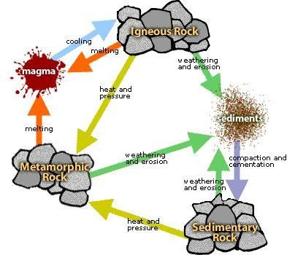
The rock cycle describes the processes through which the three main rock types (igneous, sedimentary, metamorphic) transform from one type to another.

32.a) Using a well-drawn diagram, Differentiate between soil profile and Soil catena. (6marks)
Soil profile: This is the vertical arrangement of soil in layer from the surface to the bedrock layers. Those layers are called Horizons.
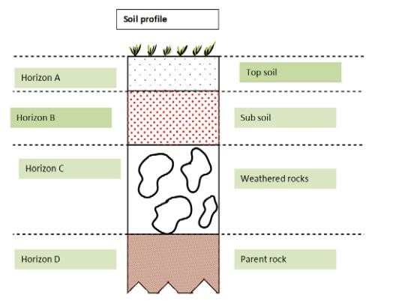
Soil catena: This refers to a soil sequence down slope with an arrangement of various soils along a given slope from the top to the valley bottom.
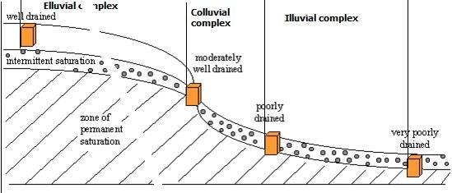
b) Describe any 4 ways that explain the importance of soils. (4marks)
- Clay soil supports Pottery and ceramics, Building and construction of activities, Medicinal use.
- loam supports agriculture activities.
- Soil has vital nutrients that support the growth of plants
- Soil support animal biodiversity, above and below ground
- Soil is used in construction
- Some soils contain valuable minerals
- Soil is important in providing and maintaining quality vegetation

33. Describe any 5 ways that explain the economic importance of rocks. (10marks)
- Rocks offer tourist attraction sites because rock out crops produce impressive features like inselbergs.
- Rocks are used for decorations at home.
- Rocks provide building and construction materials e.g. sand and cement ➢ Weathered rocks form fertile soils.
- Rocks provide traditional medicine e.g. mudstone
- Rocks are important for diet and nutrition e.g. rock salt
- Rocks promote the mining industry e.g. tin, wolfram & tungsten in Rwanda
- Rocks are used for domestic purposes e.g. Grinding stones
- Rocks form high lands which modify climate through influencing rainfall formation.
- Rocks promote the development of well-sheltered ports and harbor e.g. Mombasa
- Rocks determine the shape, nature and morphology of the landscape e.g. hills, valleys
- Rocks are used for study and research (field work)
- Rocks promote industrial development e.g. cement factories use limestone factories use chalk
- Rocks provide employment opportunities e.g. rock modeling & quarrying in Rwanda

